**Question paper I(All questions carry one mark)**

**Recall Questions**

1. Which of the following is block coefficient?
2.  b)  c)  d) 
3. The condition of static stability is given by
4. GM<0 b) GM >0 c) GM =0 d) None of the above
5. When a body is floating in a liquid, weight of liquid displaced by a floating body is equal to
6. Underwater volume * density of liquid b) underwatervolume * density of material c) total volume * density of liquid d) none of the above
7. Minimum KM of a box-shaped barge occurs at a draft given by
8. T=2B b)  c)  d) 
9. Free surface effect produces a shift in G equal to G0GV =
10.  b)  c)  d) none of the above
11. If a vessel divides a tank in a vessel into n parts longitudinally, G0GV reduces by
12. 1/n3 b) 1/n4 c)1/n2 d) none of the above
13. If a ship is turning, its lever arm of turning is proportional to
14. Cosφ b) Cos2φ c) tanφ d) sin φ
15. Which of the following is true for small angles of heel
16. GZ=GMcos φ b)GZ=GM sin φ c)GZ=GM d)none of the above
17. GM of a ship at the angle of loll will be
18. Positive b)Negative c)Zero d) none of the above
19. Parallel sinkage in cm is proportional to
20. TPC b) 1/TPC c)MCTC d)LCF

**Assignment questions**

1. Length from aft perpendicular to forward perpendicular is
2. Lpp b)Lwl c) LOA d) None of the above
3. A vessel has the following ½-areas of water plane at the drafts given

|  |  |  |  |  |  |  |  |
| --- | --- | --- | --- | --- | --- | --- | --- |
| Draft (m) | 0.25 | 0.75 | 1.25 | 2.25 | 3.25 | 4.25 | 5.25 |
| ½ area  (m2) | 800 | 1600 | 2300 | 2600 | 2750 | 2800 | 2825 |

Below the 0.25 m there is an appendage volume 150 m3 Kb 0.2 m

The waterplane area at a draft of 3.25 m would be (in m2);

1. 6500 b)5500 c)2750 d)None of the above
2. A ship of displacement 16450 tonnes has KG =9.3m and loads and discharges cargoes as below

Weight(tonnes) KG (m)

Loads 1427 8.6

2964 4.6

1930 12.0

Discharges 2000 11.8

483 6.4

What is the final displacement in tonnes?

1. 16450 b) 20288 c) 175 d) none of the above
2. Underwater volume = L ength * Breadth * Draft * X where X is
3. Waterplane area coefficient b) Block coefficient c) density d) none of the above
4. By Archimedes principle, weight of floating body is
5. Weight of liquid displaced b) weight of underwater volume c) total volume of ship * density of water d) none of the above
6. A floating body has square cross-section of side 1m and KG always equal to 0.5 m. What is minimum KM for stability?
7. 1m b) 0.5m c)0.25 m d)cannot be calculated
8. A box vessel length, 100 m; breadth, 9 m; depth, 6 m; is floating at draft 5 m. A full breadth midship compartment length 20 m contains cargo with stowage factor 1.2 m3/tonne and density 2 tonne/m3 . Permeability of the compartment is
9. 0.78 b) 0.24 c) 0.42 d) 0.58
10. When a ship turns with a linear speed V, in a circle of radius RTC, a centrifugal force, FTC, develops. FTC =
11.  b)  c)Δg d)none of the above
12. A ship heels that an angle of φ such that area under the heeling arm curve is equal to
13. Sail area b) area under righting arm curve c) wetted surface area d) none of the above
14. At the position of stable equilibrium, which of the following is minimum
15. Potential energy b)kinetic energy c)pressure d)momentum
16. In a GZ curve with the wind heeling arm superposed, how many points of equilibrium are there?
17. Three b)one c)two d)four
18. A vessel displacing 30000 tonnes is floating at drafts F 8.3 m, A 9.6 m. MCTC, 300 tonne m/cm. Centre of Flotation, 109 m forward of after perpendicular (AP), length, 210m. 1000 tonnes of ballast are moved from a tank centre of gravity 175 m forward of AP to a tank 205 m forward of AP.

Change of trim is

1. 200 cm b)100cm c) 150 cm d)none of the above
2. A vessel is about to enter a river port over a bar where the maximum depth at highwater is 9.2 m. She must have a minimum clearance of 0.5 m and is at present at draft. Forward 8.40 m, Aft 9.00 m. Water must be discharged from an afterpeak tank LCG 7 m forward of AP. TPC=25 tonne/cm; MCTC=125 tonne m/cm; LCF, midships; length=220 m.

The amount of ballast to be discharged is

1. 85 tonnes b)66.4 tonnes c)23.3 tonnes d) 152 tonnes
2. The formula to calculate GZ values from the KN curves is
3. GZ=KN-KGsinφ b) GZ=KN-KMsinφ c) GZ=KM-KNsinφ d)none of the above
4. The wall-sided formula states that
5. GZ = sinφ (GM+ ½ B0Mtan2φ) b) GZ = sinφ (GM+ ½ B0Mcot2φ) c)GZ=GM cos φ d) none

**OPEN QUESTIONS**

26.Sectional area curves are taken for

a) cross-section b)waterplane c) wetted surface d) none of the above

27. Free surface Moment is

a) G0GV b) G0G1  c) G0Gv * W d) none of the above

28. How does the stability of the ship vary with free surface effect

a) increases b)decreases c)remains same d) cannot be defined

29. The righting moment calculated by the two methods for studying bilging are

a)Always same b) different c)sometimes same d) none of the above

30.Hydrodynamic lift is produced by

a) Pressure difference d)drag force c) potential d) weight

**OPEN QUESTIONS (COMPREHENSION 8*5=40)**

Questions 31-33 are from the following problem

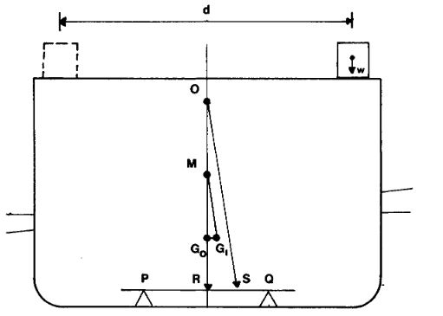

The figure above shows the apparatus for doing inclining experiment. Answer questions 31-33

1. =
2.  b)  c)  d) none of the above
3. If the vessel has a displacement W then  is
4.  b)  c)  d) None of the above
5. We can calculate the KG from
6. KM-G0M b) KM- BM c) measured d)cannot find

Questions 34-36 are from the following problem

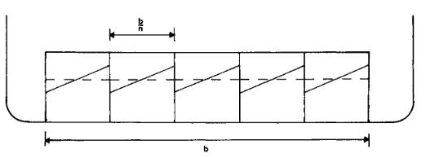

If a rectangular tank of breadth b is divided into n equal subdivisions each containing liquid of density ρ and i is the moment of inertia of the whole tank

1. If the whole breadth was one tank, the G0Gv (shift of center of gravity) is
2.  b)  c) upwards d) all of the above
3. If a rectangular tank of breadth b is divided into n equal subdivisions each, the G0Gv (shift of center of gravity) is
4.  b)  c) remains same d) none of the above
5. The tanks produce least free surface moment when they are
6. Transverse b)longitudinal c) vertical d) none of the above

Questions 37-39 are from the following figure

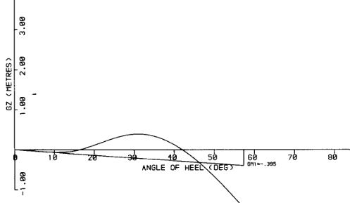

1. The ship becomes stable at an angle of
2. 0 b) 17 ͦ c) 30 ͦ d)50 ͦ
3. The angle of vanishing stability is
4. 0 b) 42 ͦ c) 60 ͦ d) cannot be determined
5. The area under the curve is called
6. Damaged stability b) Dynamic stability c) positive stability d) None

Questions 40-42 are from the two figures.

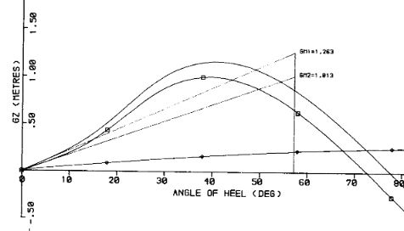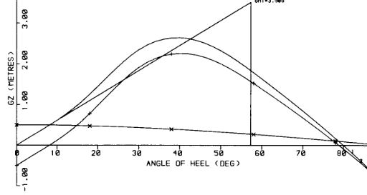

1. The figure on the left is when
2. Weight is shifted horizontally b) Weight is shifted vertically c) Damaged stability 4) None of the above
3. The figure on the right is when
4. Weight is shifted horizontally b) Weight is shifted vertically c) Damaged stability 4) None of the above
5. When the weight is shifted vertically up the GM
6. Decreases b) Increases c) remain same d) cannot be sure

Questions 43-45 are from the following problem;

On board a vessel displacement W with centre of gravity at G0 there is a rectangular tank length l and breadth b containing liquid density ρ (See Figure below.) The vessel is inclined by an external force to some angle of heel Θ. A wedge of liquid moves across the tank, the centre of gravity of the liquid moves from g0 to g1. Then if the wedge of liquid has weight w

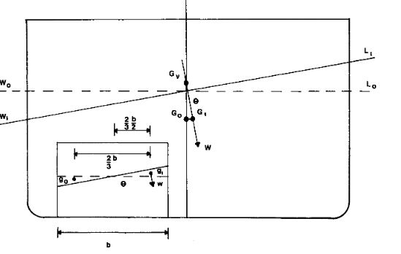

43. Weight of the wedge w=

a) b)  c)  d) none of the above

44. g0g1 =

a)  b)  c)  d) None of the above

45. G0G1=

a)  b)  c) gog1 d) none of the above

Questions 46-48 are from the following table;

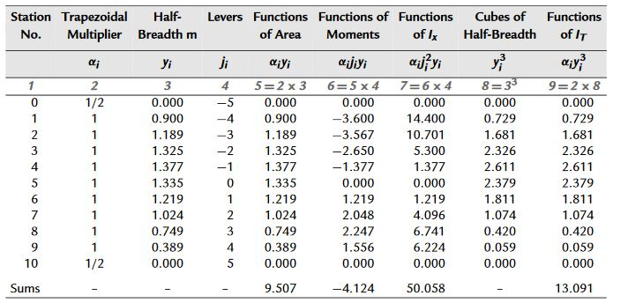

For this problem, δL=0.893 m

46. The area of waterplane is

a) 16.98 m2 b) 23.25 m2 c) 120.28 m2 d) none of the above

47. LCF is

a) -0.254 m b)-0.387 m c)0.387 m d)0m

48. The transverse second moment of area about the centerline (IT in the table)

a) 7.79 m4 b) 2.34 m4 c) 34.32 m4 d) none of the above

49-51 are from the following problem.

A vessel displacing 11 500 tonnes has KG=7.5 m; KM=8.4 m and is listed 4 degrees to port. The vessel has yet to load 750 tonnes. Space is available at Kg=10.5 m, 6 m to port of centerline and at Kg=8 m, 4 m to the starboard of the centerline. The cargo is distributed so that the vessel completes upright.

49. The final KG is

a) 7.57 m b) 8.67 m c) 2.12 m d) None of the above

50. Weight to be added at Kg=10.5 m is

a) 123.4 tonnes b) 227.7 tonnes c)200.4 tonnes d) None of the above

51. G0M =

a) 1.0 m b)0.9 m c) 0.5 m d) None of the above

52-54 are from the following problem and table;

The following ship is displacing 26000 tonnes and has KG=9.6 m.

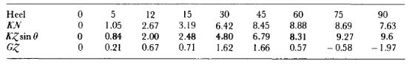

52. Does GM satisfy the loadline regulations?

a) Yes b) No c) sometimes d) None of the above

53. Area under GZ-heel curve from 0 ͦ-30 ͦ equals

a) 0.6 mrad b) 0.8mrad c) 0.4 m rad d) None of the above

54. Does the ship comply with load line regulations for area from 0 ͦ-30 ͦ ?

a) Yes b) No c)sometimes d) None of the above